NOTES TO USERS
- PLEASE PUT THIS ON YOUR COMPANY LETTERHEAD
- USE ONE FORM FOR EACH PRODUCT AND/OR CERTIFICATION

DECLARATION OF BIO-BASED AND BIODEGRADABLE PRODUCT CERTIFICATIONS
Name of company

TIPA® Corp

Address

3 Hanagar St. Hod Hasharon, Israel 4501306

Contact person for further information

Julia Vol

Email contact

vol.julia@tipa-corp.com
Name or brand of biodegradable or biobased product sold into the UK market
LAM 604
Photo of product as marketed (attached as jpeg)

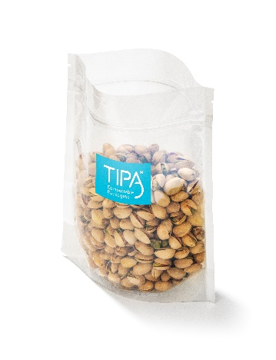 See corresponding attached photo titled LAM 604
Type of certification obtained for each product

Seedling
OK Compost Industrial
(For example, compostability CEN13432, soil biodegradability CEN17033, non toxicity, food contact, renewable carbon C14, other)
Name of certification body for the certification

Din Certco
TUV Austria

Code Number of the certification

7P0741
TA8011601645

